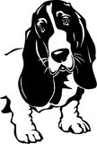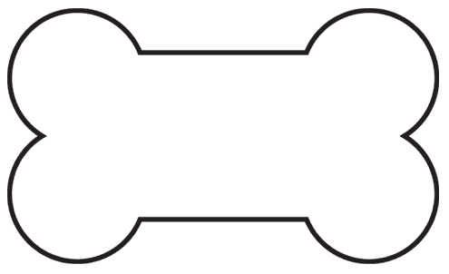

**Kidz Klub**

**Today at NDOG Kidz Klub**!

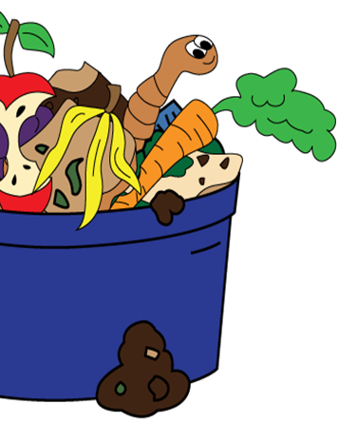

**Let’s Make Worm Castings**

**(a.k.a. Worm Poop!)**

**Today the kids will learn about composting with worms . . .**

**They will get to play with the**

**worms and learn how worm “poop” can make one of the best fertilizers, with nutrients to grow healthy strong plants.**



